Safeguarding Adults  Tell us your concern |  |  |  | 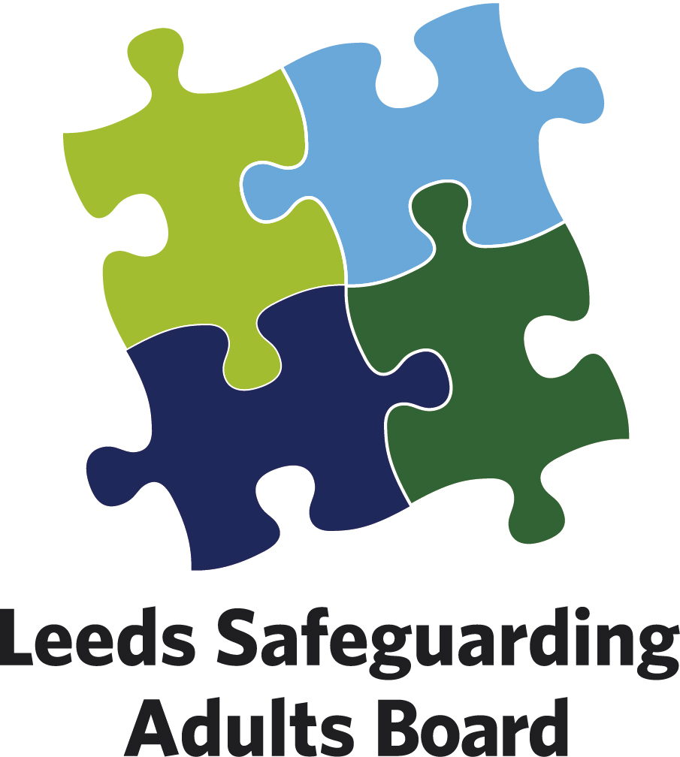

You can report concerns by either:

- Telephone: Adult Social Care Contact Centre on 0113 222 4401

Where urgent and outside of these hours ring the Emergency Duty Team on 07712 106 378

- Or complete this form and send by secure email to: Leedsadults@leeds.gov.uk

Please complete this form with as much information as possible.
Leave blank those questions you are unable to answer.

Date Safeguarding Concern Raised:

1. Who is the person at risk? | CIS ref (If known):

Title:  Mr/Mrs/Ms/Other* | First Name(s): |  | Surname: |  | Date of Birth:  Age:
Address:  Post Code:  Tel: |  |  | NHS Number (if known):
 |  |  | Gender:
 |  |  | Language spoken:
 |  |  | Communication needs:
 |  |  | Ethnicity:
 |  |  | Religion:
 |  |  | Marital status:
Primary Support Reason:
Physical support needs  (exc. sensory support needs) |  | Mental health support needs  (excluding dementia) |  | Support for learning disability
 |  |  |  | Support for substance misuse
Sensory support needs |  | Support with memory / cognition (including dementia) |  | Other (please specify below)  ________________________
Carer support needs

2. What existing professional/care/support services is the person receiving (if any)?

3. Details of the safeguarding concern
(A) Describe what has happened, when and where. (B) What are the person at risk’s views about this
(C) Describe the risks or any injuries or harm experienced by the person at risk
Please tick here if a Body Map has been completed
Type(s) of abuse
Physical |  | Domestic abuse |  | Financial / Material
Neglect / Acts of omission |  | Discriminatory |  | Organisational
Psychological |  | Sexual abuse |  | Self-Neglect
Modern slavery |  | Sexual exploitation |  | Tick all that apply

4. What does the person at risk want to happen now?
4a. What are the desired outcomes of the person at risk? That is, what do they wish to achieve from the support they might receive, such as feeling safe at home or having no contact with certain individuals
Has the person at risk given consent for these concerns to be raised? | Yes No Not Sure
Did the person have mental capacity to give consent? | Yes No Not Sure

5. Actions taken in relation to the safeguarding concerns?
Details of action taken:

Have the police been informed? | Yes No | Crime Ref. Number:
Has medical intervention been sought? | Yes No | From where/whom?

6. Details of the person or organisation alleged to be responsible for the abuse or neglect
Name: |  | Date of Birth:
Address:  Post Code: |  | Gender:
Address:  Post Code: |  | Does the person/organisation know that a safeguarding concern has been raised?  Yes No Not Sure
What is their relationship to person at risk?  Are they known to the person at risk? Yes No |  | Is this person also an adult at risk? Yes No
Additional information, such as previous concerns:

7. Any other relevant information
Include any safety or confidentiality issues that may impact on how the concern is acted upon

8. Details of the person completing this form
Name: |  | Job Title:
Address:

Post Code:
Tel: |  | Date:

